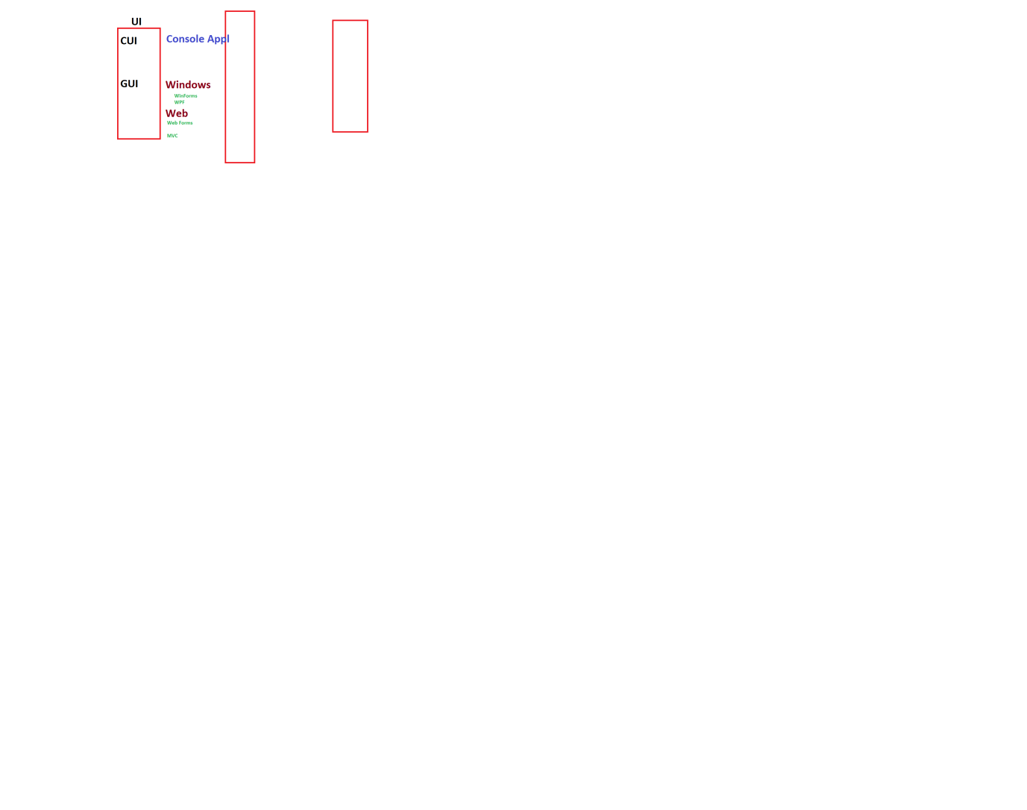

ChildControls > Controls in other controls

<div> <p> </p> </div>

<windows>

<grid>

<grid>

<TextBox>

<Label>

<Button>

</grid>

</grid>

</windows>

<Window x:Class="WPF_Demo.MainWindow"

xmlns="http://schemas.microsoft.com/winfx/2006/xaml/presentation"

xmlns:x="http://schemas.microsoft.com/winfx/2006/xaml"

xmlns:d="http://schemas.microsoft.com/expression/blend/2008"

xmlns:mc="http://schemas.openxmlformats.org/markup-compatibility/2006"

xmlns:local="clr-namespace:WPF_Demo"

mc:Ignorable="d"

Title="MainWindow" Height="650" Width="800">

<Grid>

<Grid.ColumnDefinitions>

<ColumnDefinition Width="100"></ColumnDefinition>

<ColumnDefinition Width="auto"></ColumnDefinition>

<ColumnDefinition Width="100"></ColumnDefinition>

</Grid.ColumnDefinitions>

<Grid.RowDefinitions>

<RowDefinition Height="100">

</RowDefinition>

<RowDefinition>

</RowDefinition>

</Grid.RowDefinitions>

<Label Content="Hello World" Grid.Row="0" Grid.Column="0" FontSize="30" FontStyle="Italic"/>

<Label Content="Hi World" Grid.Row="0" Grid.Column="1" FontSize="30" FontStyle="Italic"/>

</Grid>

</Window>

------------------------------------------------------------------------------------------

TextBox bind it with n variable

Int n =7;

One way

Two way